Book Tracker API

Project Report

by

P Vamsi Krishna

Project Documentation

# **Project Title: Book Tracker API**

## **1. Introduction**

This project is aimed at building Book Tracker API.

The system addresses challenges in manual leave tracking and payroll calculation by providing an automated Fast API + MongoDB solution.

## **2. Problem Statement**

Difficulty in tracking employee leaves manually.

Payroll errors due to untracked leave balances.

Lack of centralized data storage for employees.

## **3. Proposed Solution**

Develop a Fast API + MongoDB application.

Allows Adding desired books to repository with respective

user. Also perform updating and delete books user desired.

## **4. Project Features**

Book Management: CRUD Operations for book repository

## **5. Technology Stack**

Backend: Python (Fast API)

Database: MongoDB

Authentication: JWT Tokens

## **Abstract**

The **Book Tracker API** is web application designed to help user manage and monitor their personal reading list. Built using **FastAPI**, a modern Python web framework, and **MongoDB,** a flexible NoSQL database, the system enables users to perform full CRUD operations on book records. The project lays the groundwork for a full-fledged book management platform and serves as a foundational backend for potential frontend or mobile applications. It is suitable for personal use, academic demonstration, or as a starter project for larger book-related platforms

## **Introduction**

In an age of digital consumption, managing personal reading habits can be both enriching and overwhelming. The **Book tracker API** is designed to simplify the process of tracking books, monitoring reading progress, and organizing a personalized library. This backend service built using FastAPI, a modern, high-performance Python web framework, and mongoDB. It provides **user authentication (JWT)**, ensuring that each user can only access and manage their own books. This project demonstrates the use of **modern backend technologies** and sets the foundation for integration with frontend applications or mobile app

## **Screenshots**

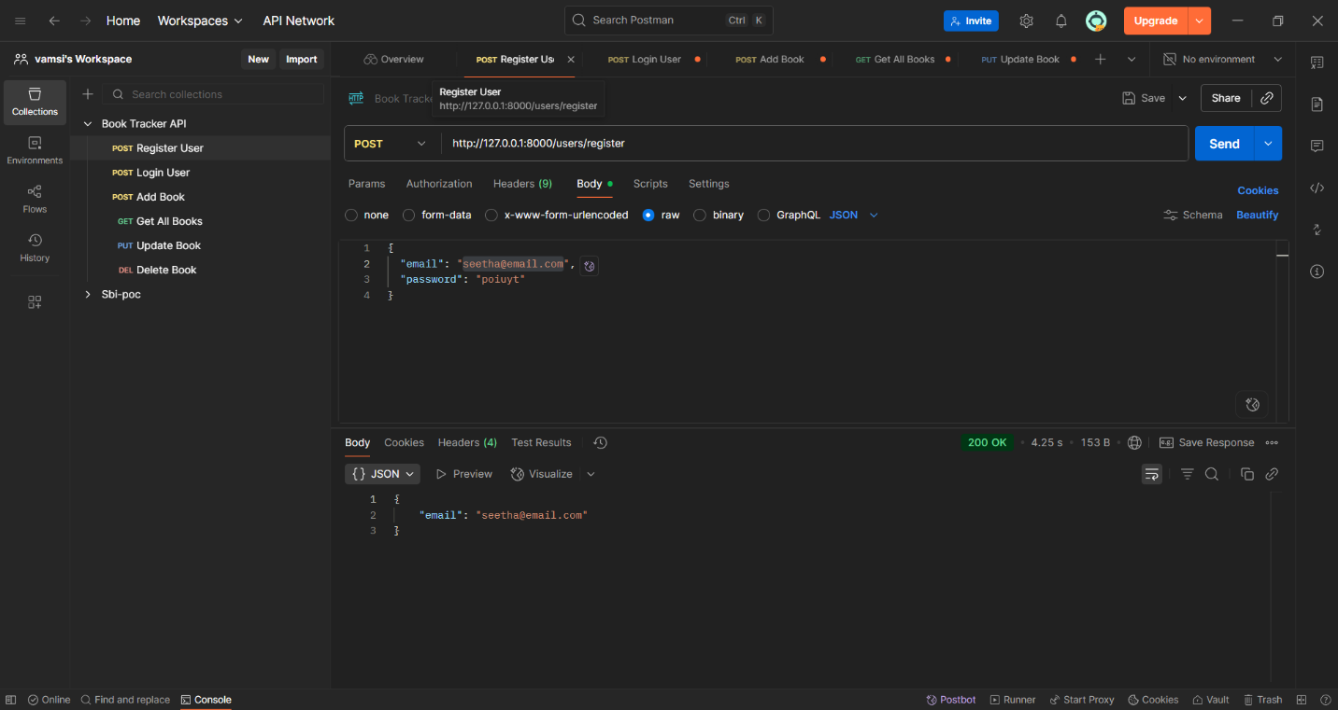

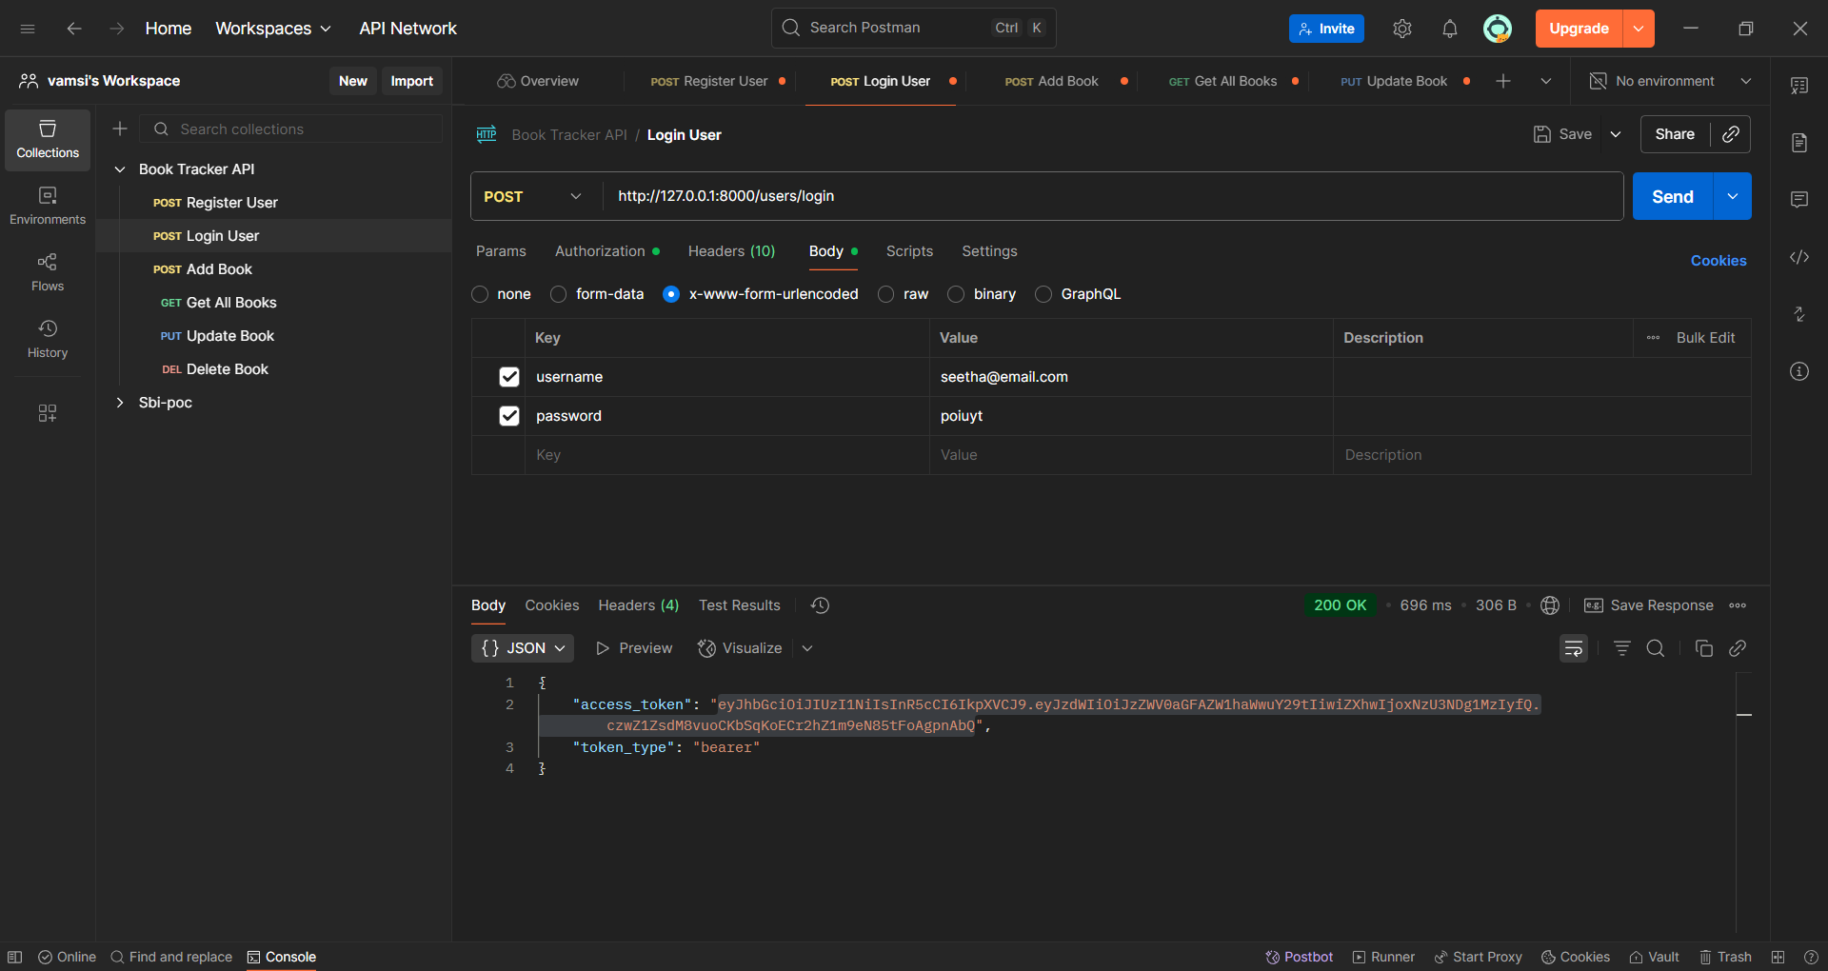

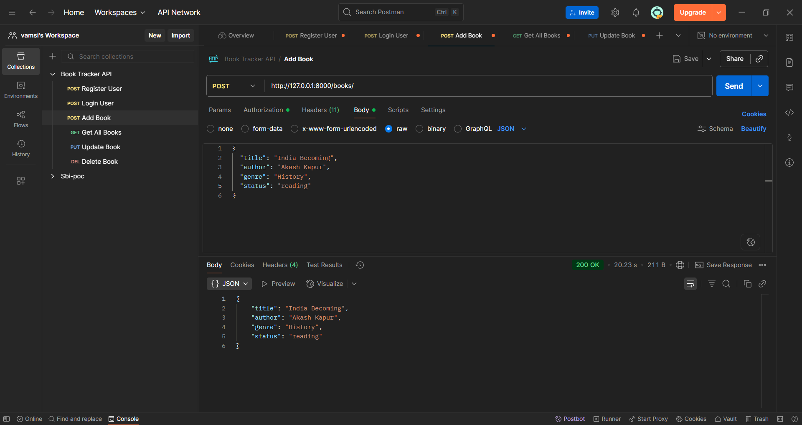

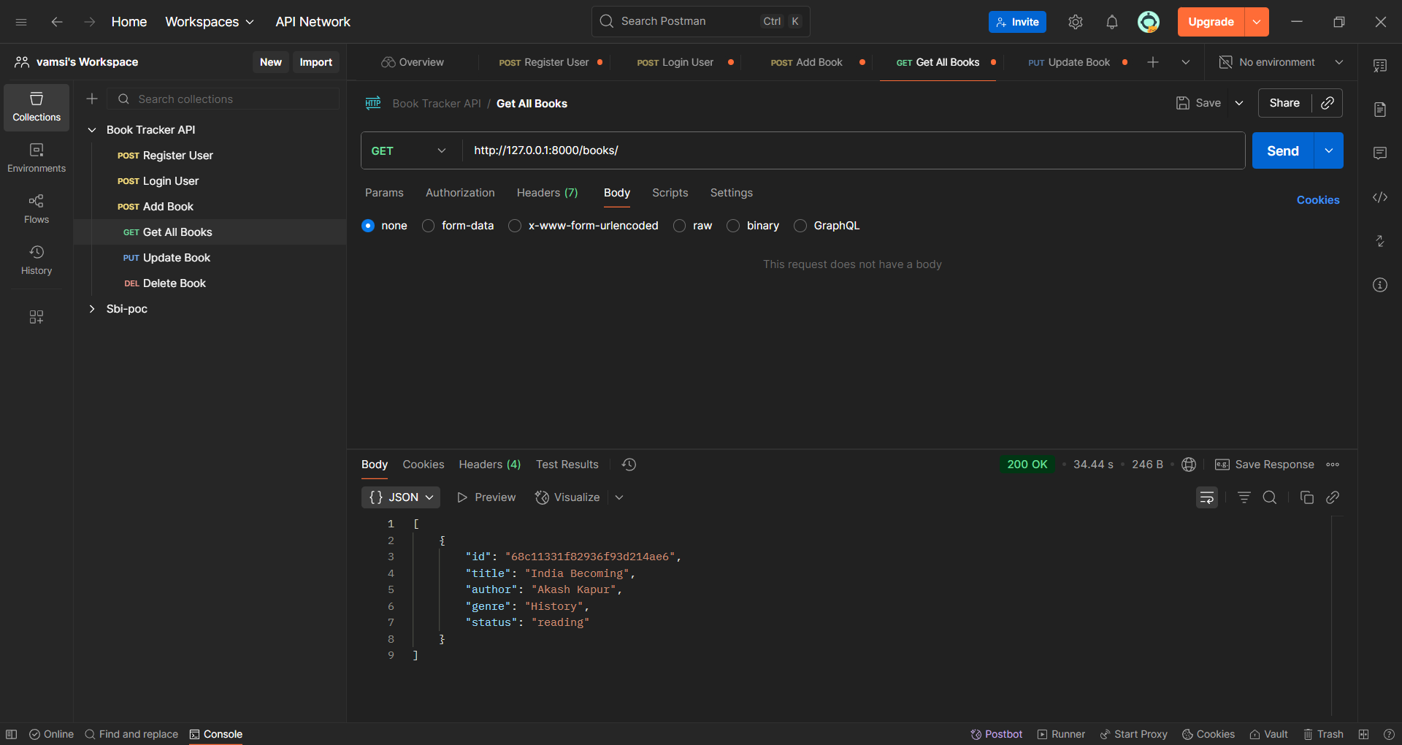

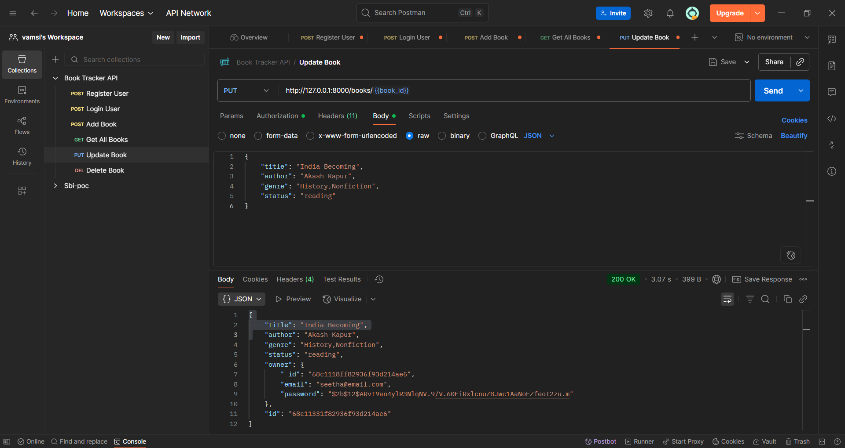

## **Conclusion & Learnings**

The **Book Tracker API** successfully demonstrates how to build a secure, scalable, and user-centric backend application using **FastAPI** and **MongoDB**.  
It provides **JWT-based authentication** to ensure data privacy, supports **user-specific CRUD operations** for managing books, and integrates **logging and error handling** for reliability.

In summary, the project achieves its primary goal of enabling users to **securely track and manage their personal book collections**, while also being production-ready and extendable.